CSE 3100: Web Programming Laboratory

Lab 8: Laravel Migration &

Database Designing

# Create a Laravel Project

* Open Terminal in your VS Code . Shortcut: *Ctrl+`*
* Go to the htdocs folder in the terminal :

*cd C:\xampp\htdocs*

* Create a Laravel project: *composer create-project laravel/laravel test-app*
* Open the project in VS Code:

*cd test-app*

*code .*

* Start Laravel built-in server:

*php artisan serve*

# Form processing, CSRF protection

Create a folder under views named “products”. Now,generate create.blade.php , edit.blade.php , index.blade.php files in the folder. We can use routes to view these pages.

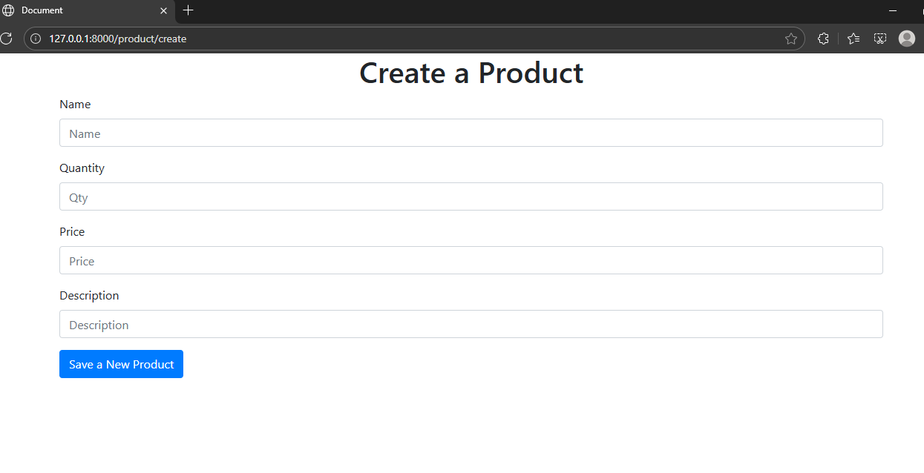

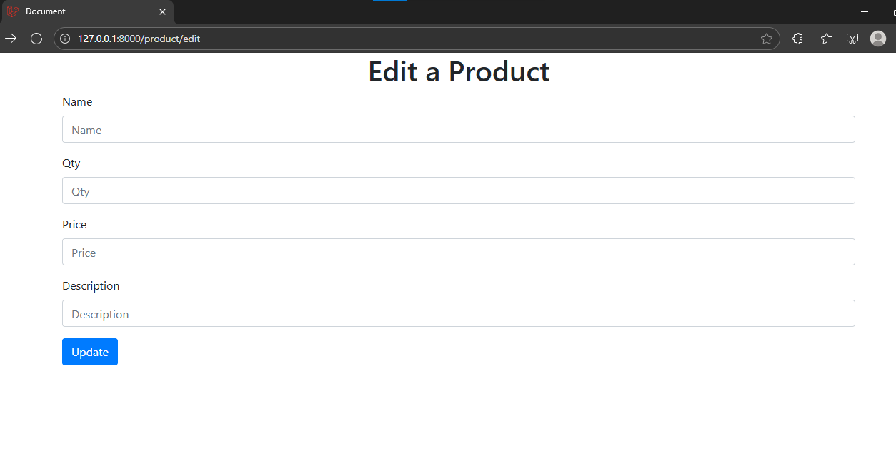

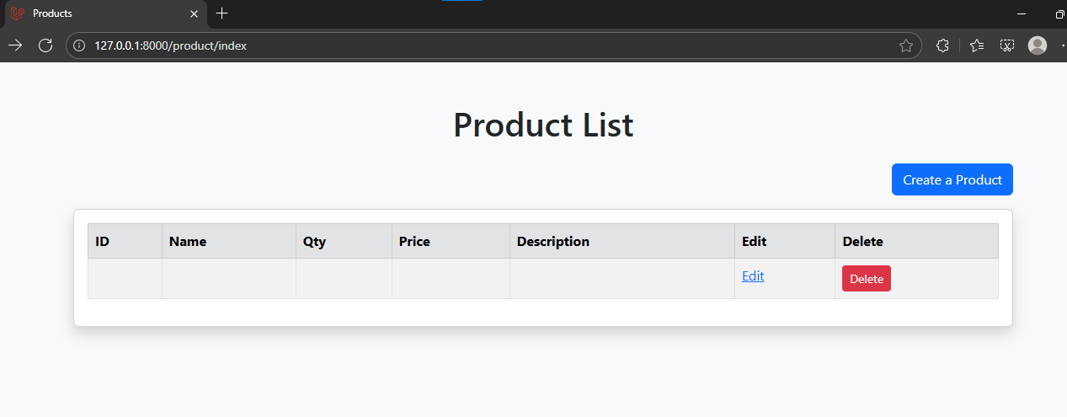

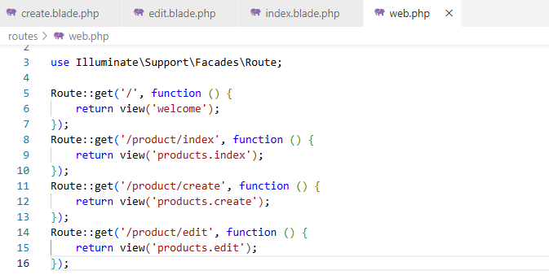

# Adding Form Validations

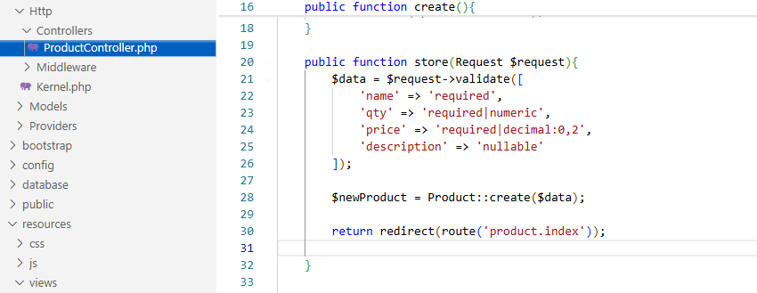

# Apache & MySQL

First open your XAMPP Control Panel and turn MySQL services on along with the Apache server.

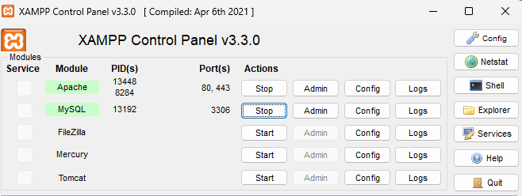

# Create Database

Paste *http://localhost/phpmyadmin* URL in your browser to open phpMyAdmin. Create database same as your application name

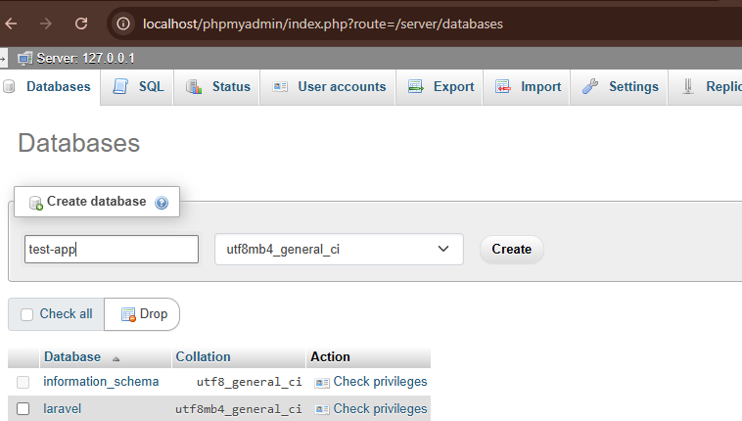

Now, copy your database name and go back to your project in VS Code and open the .env file . Change the DB_DATABASE to your created database’s name.

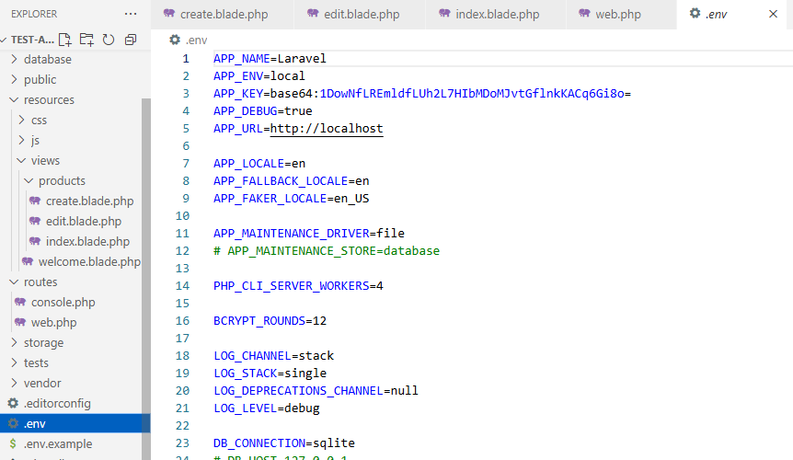

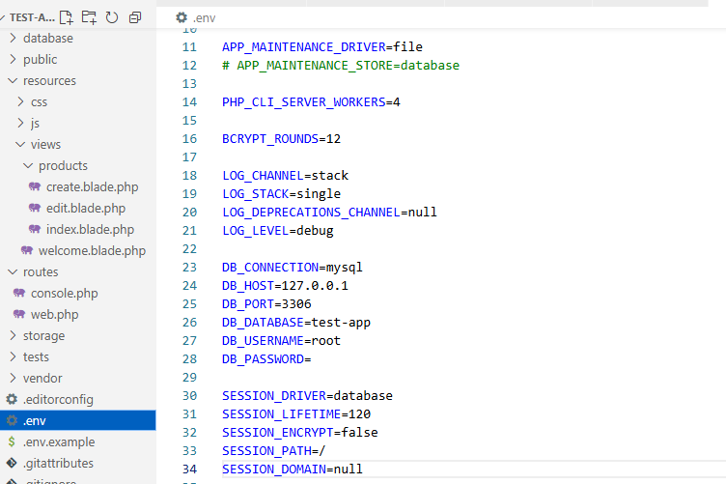

# Connect Laravel App with Database

Create new terminal and write:

php artisan migrate

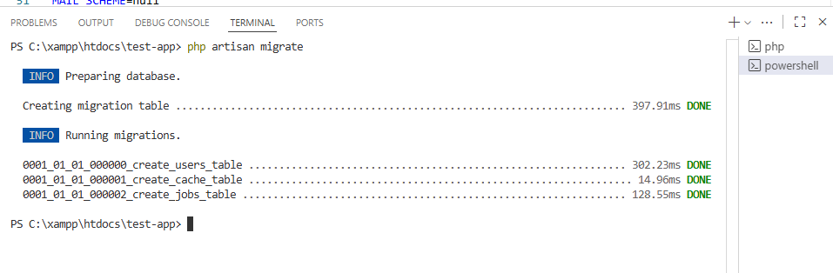

If you go to the database in phpmyadmin, you will find some newly created tables. These are default tables of Laravel

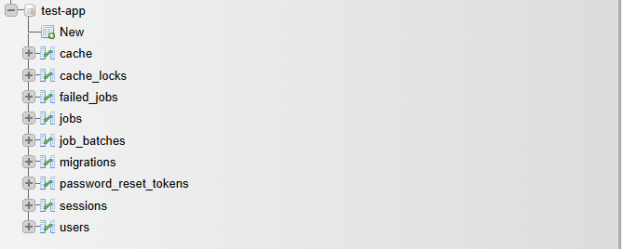

# Create a Table in Database using Migration File

Now, we will create table using migration [<https://laravel.com/docs/12.x/migrations>]

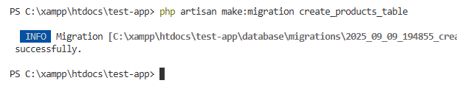

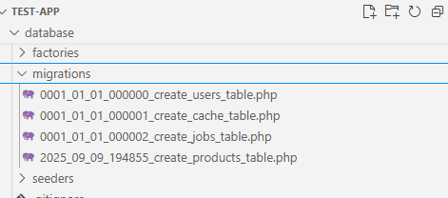

Now we will add columns to the table.

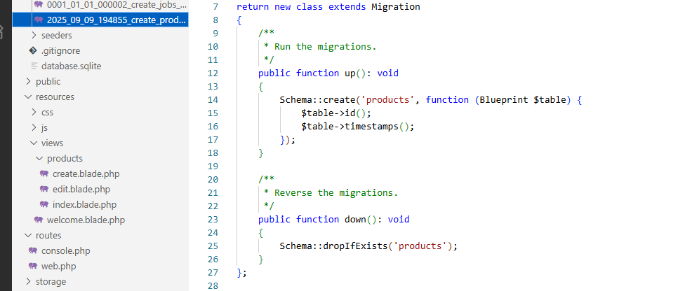

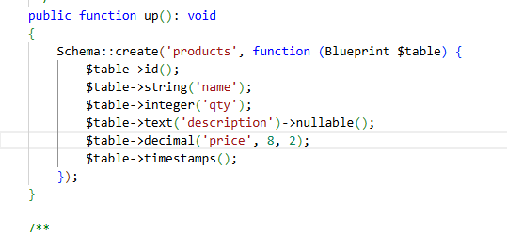

Check the available column types from [Laravel Documentation](https://laravel.com/docs/12.x/migrations)

Now , go to the terminal and write *php artisan migrate* to create the table.

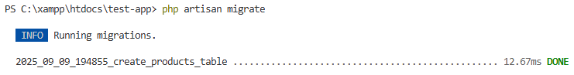

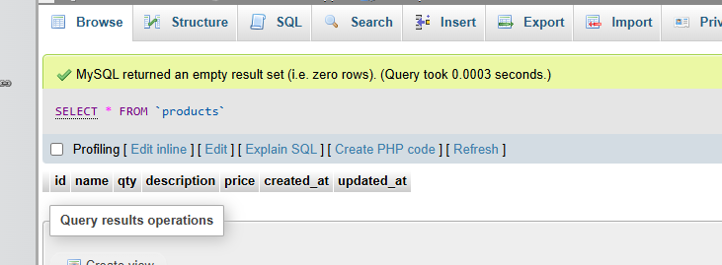

# Create Laravel Model

We will use Artisan Command to generate a new model:

*php artisan make:model Product*

For better understanding visit: <https://laravel.com/docs/12.x/eloquent>

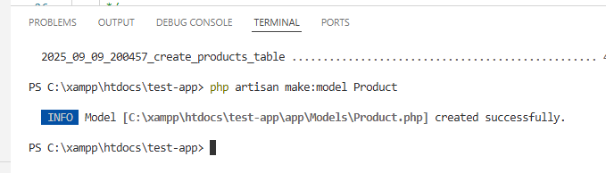

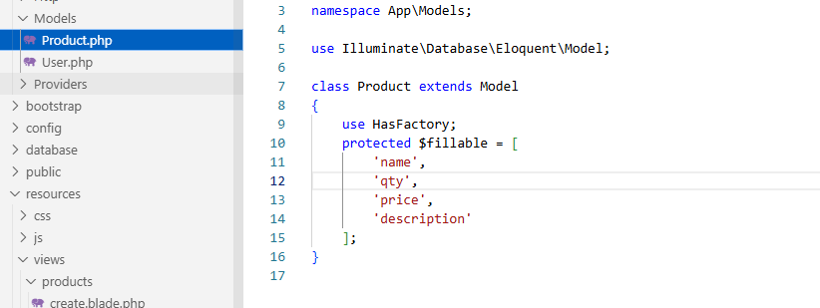

# Create Laravel Controller

For better understanding visit: <https://laravel.com/docs/12.x/controllers#main-content>

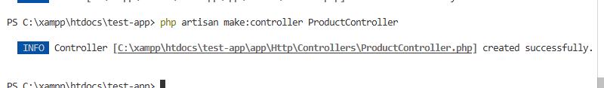

# Create a First View File

# Create Route

Now, we will do routing using the controller class. As we have a total of 3 view files, we will create a route for each of them. Let's start with creating a route or viewing create.blade.php file. Firstly, create a function in ProductController.php that will view create.blade.php file

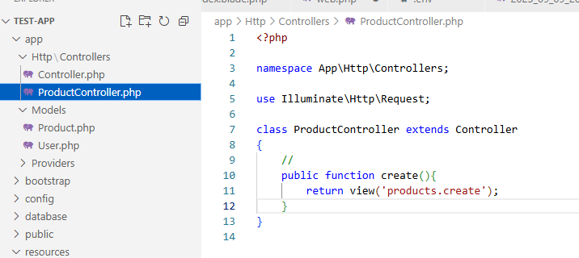

Then, add Route in the web.php file. Remember to add namespace in the web.php file.

use App\Http\Controllers\ProductController;

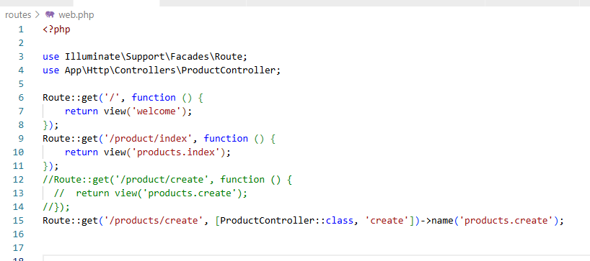

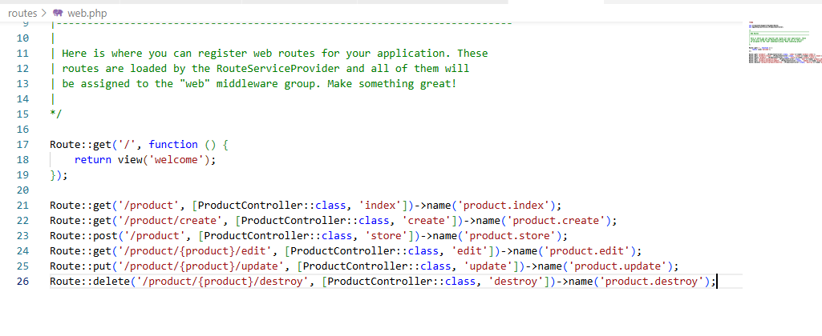

# Insert Data

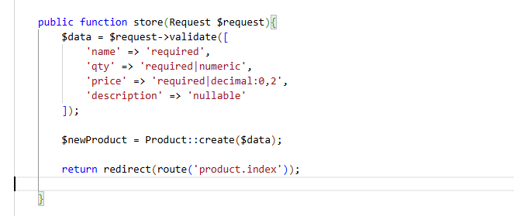

# Read Data

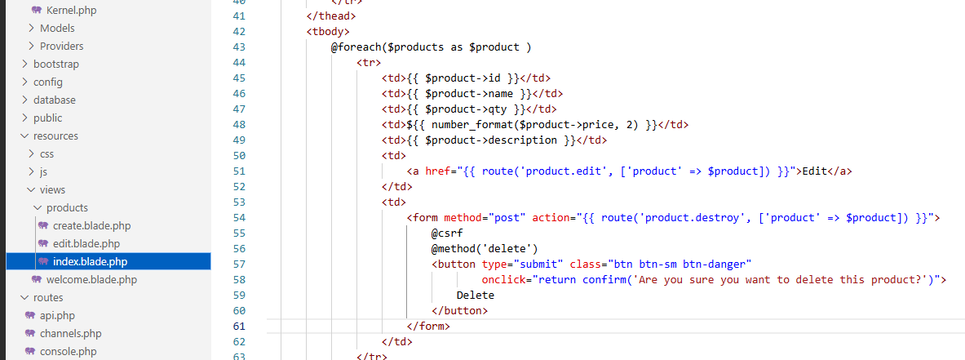

# Update Data

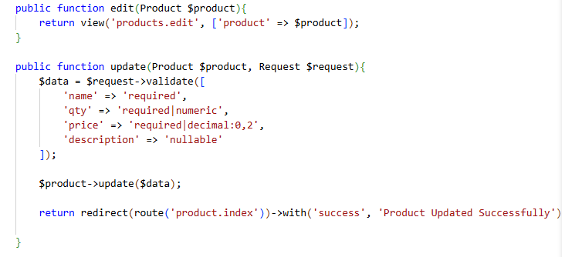

# Delete Data

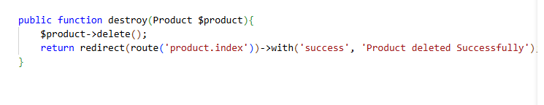

We need to use @csrf inside the form tag. In Laravel, @csrf is used inside Blade form to protect it from CSRF attacks (Cross-Site Request Forgery). Without @csrf you will get an error.